### Experience

Software Developer **-** January 2023 – December 2023

**Tie Product Development B.V., Breukelen, Netherlands**

* Identified ways to improve design and development.
* Built web pages that are more user-interactive using ES6, Typescript, Angular 15 and NgRx.
* Involved in design and development using HTML5, CSS3 and Angular material.
* Involved in design and development of reusable components.
* Collaborated with UX designers and backend developers to ensure coherence among all parties.
* Implemented containerization using technologies such as Docker to improve application deployment and scalability.
* Written test cases for the functionality using Jest.
* Proficiency in maintaining design systems and distributing reusable components and styles across multiple product teams.
* Worked on GIT as a version control. Worked on GIT repositories & sub-repositories. Utilized NPM scripts for build and test environments.

Senior Associate **-** September 2021 - December 2022

**Price Waterhouse Coopers (PwC), India**

* Responsible for creating efficient design and developing User Interaction screens using HTML, SCSS, Bootstrap & Angular 13.
* Written test cases for the functionality using Jasmine karma.
* Employed Webpack for efficient asset compilation and bundling.
* Designed and developed the application using Agile Scrum methodology by breaking down the project to several sprints.
* Architecture decisions, focusing on scalability, maintainability, and adherence to industry best practices.

### Skill Highlights

* Version Control System: GIT
* Source control repository: Bitbucket
* OS: Windows 10, Linux
* SDLC: Agile Scrum
* Development Tools: Visual Studio Code
* APIs: RESTful APIs
* Languages: JavaScript, Typescript
* Web technologies: AJAX, JSON
* State Management: NgRx
* Javascript libraries: Rxjs, lodash, jQuery
* UI component library: Angular material
* Code Quality: ESLint, TSLint
* Build Tools**:** Webpack
* CSS preprocessor**:** LESS, SASS, SCSS, BEM methodology
* CSS frameworks: Bootstrap, Tailwind CSS
* Testing Frameworks: Jasmine, Jest
* End to end testing: Cypress Cucumber.
* CI/CD, Jenkins, Azure, Kubernetes, Docker.

Sonali Soni

Phone : +31 620725412

Address: Utrecht, Netherlands

E-mail : [sonalisoni246@gmail.com](mailto:sonalisoni246@gmail.com)

Linkedin : https://www.linkedin.com/in/sonali-s-782a17185/

Results-driven Senior Angular Developer with over 8 years of hands-on experience leading and contributing to the development process.Skilled in guiding development processes and making sound architectural decisions. A continuous learner, I stay abreast of emerging trends in software development, consistently offering innovative solutions to elevate digital platforms. With a commitment to excellence and a strategic mindset, I am well-equipped to contribute effectively in diverse and dynamic work environments.

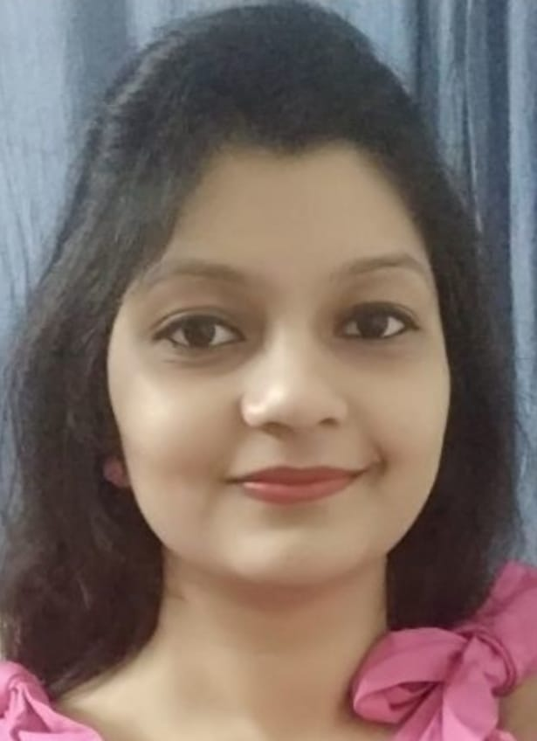

### Languages & Frameworks

* Angular
* Angular material
* Javascript
* Typescript
* NPM
* jQuery
* HTML
* Taiga UI
* CSS
* Tailwind CSS
* Bootstrap

### Education

**Bachelor of Engineering (B.E.) Electronics and Communications**

(Shri Vaishnav Vidyapeeth Vishwavidyalaya, Indore, Madhya Pradesh, India)

### 2011-2015

### Achievement’s

* Best employee award for 3 consecutive years in TCS.
* Trend setter award for new innovations.
* Critical Resource Project Award.

### Experience

Consultant **-** November 2019 - September 2021

**Capgemini Technology Services India Ltd,** **India**

* Responsible for creating efficient design and developing User Interaction screens using HTML, CSS3, Bootstrap, JavaScript, Angular 6.
* Enhanced application performance by Angular 6 Component based development in view of future Angular framework transitions.
* Experience with creating custom directives, decorators, and services to interface.
* Implemented Angular Router to enable navigation from one view to the next as customer performs application tasks.
* Used AJAX, JSON to send request to the server to check the functionality of the websites and for storing and exchanging information between browsers and servers.
* Worked on GIT as a version control. Utilized NPM scripts for build and test environments.
* Designed and developed the application using Agile Scrum methodology by breaking down the project to several sprints.

**System Engineer -** September 2016 - September 2019

**Tata Consultancy Services (TCS),** **India**

* Identify ways to improve design and development.
* Built web pages that are more user-interactive using ES6, Typescript and Angular 6.
* Involved in design and development using HTML5, CSS3 and Bootstrap 3 technologies.
* Involved in design and development of reusable components.
* Manage task effectively prioritize accordingly.
* Creating templates of the website using the framework and developing custom components, widgets as per the requirements
* Creating templates of the website using the framework and developing custom components, widgets as per the requirements.
* Responsible for designing page layout using HTML5, CSS3 along with jQuery and adding dynamic functionality to each module.
* Testing of components and templates, Cross-browser/MacOS/Windows.
* Training of new employees on basic understanding of jQuery and JavaScript.

11/2015 to 03/2020

**Java (AEM) Developer**

**TCS** **, India**

* Motivate and coach employees to meet service, sales, and repair goals.
* Create and modify employee schedules with service levels in mind.
* Recruit and hire top mechanics, service advisors, and sales people.
* Maintain detailed logs and reports of services performed, profit, and budget information.
* Help out in sales and repair areas as needed and maintain comprehensive current knowledge of operations.